**MA INTERACTIVE MEDIA 2012**

**KRISHNAN VIJAYARAGHAVAN – TEAM 1**

**PROJECT 2 - INTERACTIVE NARRATIVE**

**UNIT 1.2 USER EXPERIENCE, USER CENTERED DESIGN & USABILITY**

**25.01.2013**

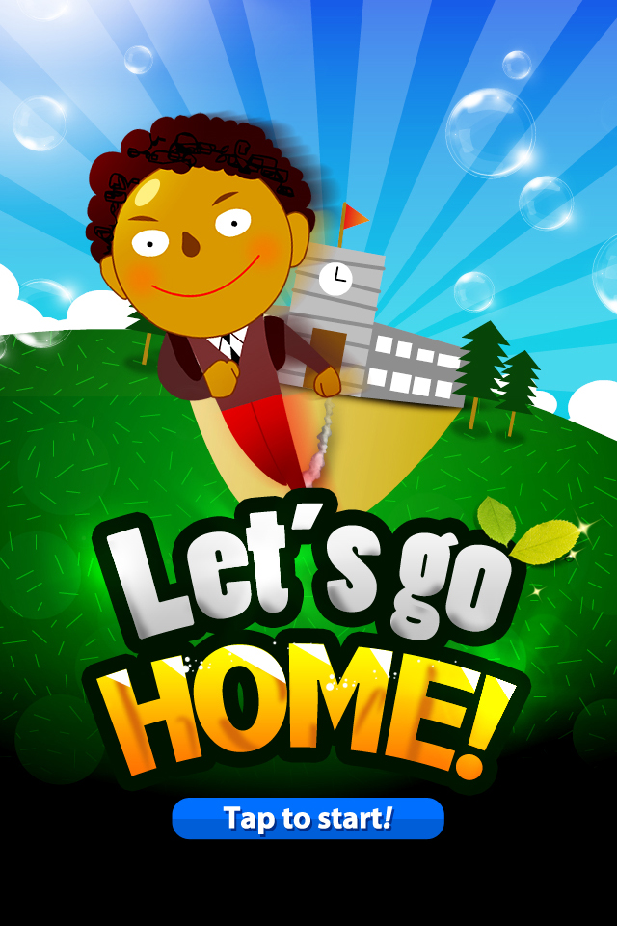

1.**PRELIMINARY USER RESEARCH:**

**Our User Group:** Primary School Children (ages 9-11) who generally walk back home alone from school and their Parents.

**Findings of User Needs:** During our brainstorming sessions for a good concept for our project, we came across an article, which talked about how the roads in Elephant & Castle are becoming death traps for school children **[1]**. With this we decided to move in this direction, which mainly focused on – school kids & their safety. We realized that we needed to create a mobile app has to do the following:

1. The app will be used by the parent for monitoring and provide supervision of the child walking back home alone.
2. For the children, we needed to create an engaging (e.g. a game) and educational experience so that they can be trained to walk alone safely avoiding crime zones and be aware of road safety.
3. The app for the children should not endanger them from phone snatchers and also distract the child in traffic sensitive areas where they have to be very observant.

**User behaviors identified:** Since it was hard to do research on our user group and we were on running on a tight deadline, we decided to do a quantitative study on their habits. We made a survey form containing 8 carefully selected questions and it was given to 30 parents. 24 parents got back to us with their feedback and the results are given below:

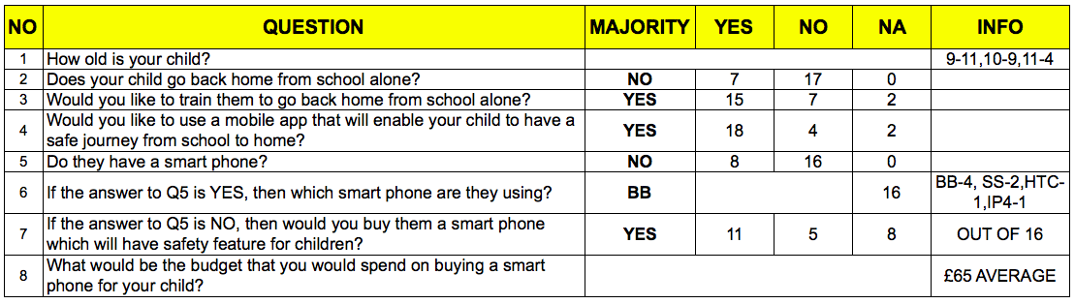

With this data from the survey, we understood the following behaviors:

1. Majority of the parents want to train their children to go back home alone after school.
2. The children do not own mobile phones, but they would buy them one with a price point of at least £65, if it provides a safety feature for the children.

**Critique:** Our user group being primary school children, we expected the research and usability studies to be challenging due to security issues, and going through school management and finding the right places to talk to them.

Had we been a bit more assertive and explored a bit more options like going to parks and family spots, we may have succeeded in doing a proper qualitative method of doing our research. We could have observed how they use technology, and what preferences both parent and children have, what apps they use etc.

As we did a quantitative study, we did not have the advantage of having open-ended questions and be able dig deeper for information. Also, for our quantitative study we should have had a much bigger sample size. We could have been a bit more assertive here again, by conducting survey in more schools. A small sample size does not hold good when doing a quantitative study, as behaviors will vary based on communities, economic backgrounds etc.

2. **PAPER PROTOTYPE TEST:**

**MAIN FINDINGS & RECOMMENDATIONS:**

**Task 1 for Child User:**

|  |  |  |  |
| --- | --- | --- | --- |
| **SECTION** | **TASK** | **RESULT** | **OBSERVATIONS** |
| Search Location | How can you do a search for the shopping centre? | 1/4 User failed | Most users passed the test, as we had used a standard and recognisable icon for the search functionality.  **Why:** The user was first confused whether she had to find it on the map. This happened because she had missed the icon for searching within the map, but later found it. |

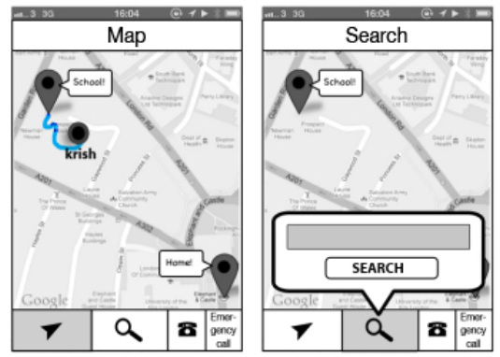

**Recommendations for Task 1:**

1. We should use text and icons to represent buttons, as this is a better practice of usability and easier for the user to understand functionality of the button.
2. We should make the icons in the bottom button bar much bigger.

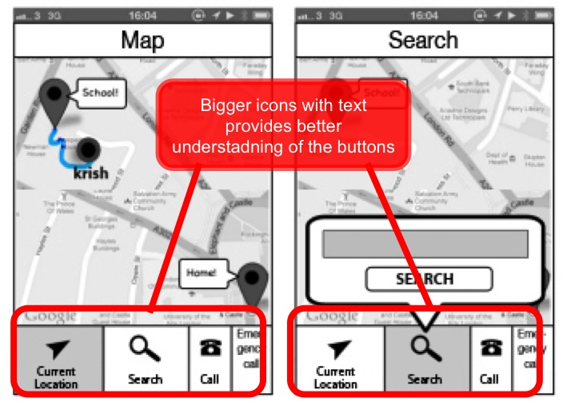

**Task 2 for Child User:**

|  |  |  |  |
| --- | --- | --- | --- |
| **SECTION** | **TASK** | **RESULT** | **OBSERVATIONS** |
| Answer Quiz | What can you do when you don’t know the answer to the question? | 2/4 User failed | Both users failed to tap the “More Info” button to see the instructional video and taped on all the options to see which one is correct.  **Why:** The button text is not providing enough information. |

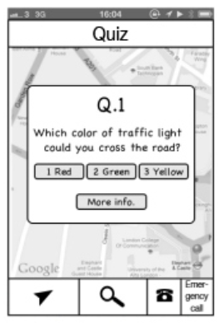

**Recommendations for Task 2:**

1. We should change the text of the button to “Watch Video” or “Video Hint” so that the user can understand the by taping the button and watching the video they will be able to answer the question.

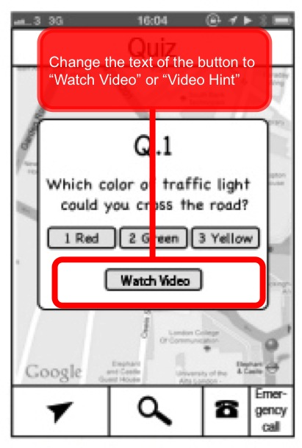

**Task 1 for Parent User:**

|  |  |  |  |
| --- | --- | --- | --- |
| **SECTION** | **TASK** | **RESULT** | **OBSERVATIONS** |
| Change settings | How can you change the details of your child? | 1/4 User failed | User failed to realise that the details of the child can be updated through the settings page.  **Why:** The word “settings” may not provide enough information to the user that they can update details. |

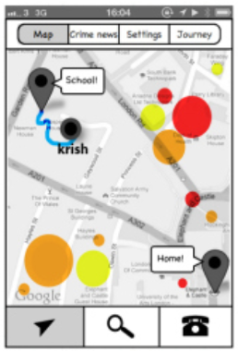

**Recommendations for Task 1:**

1. We should change the text of the tab to “Your Info” so that the user may understand that they can understand they can change their details here.

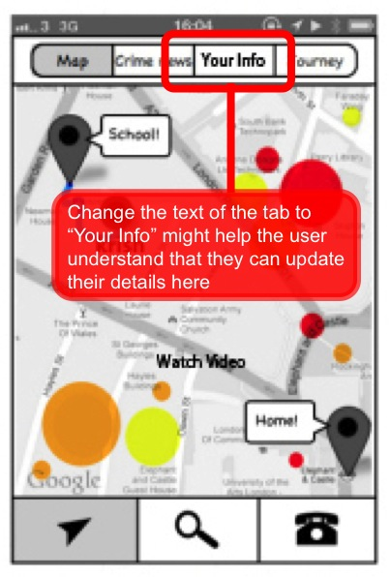

**REFLECTION:**

For our paper prototype test, we made cut outs of our wireframe prints, which were the having the same size of a smartphone screen. We used these cutouts and changed it as per the storyboard when our test user was giving inputs.

Paper prototyping may not be as effective for children compared to adults, as they may not understand how and why it is done. Without the graphical elements in place and the smooth automated interaction possible, young kids will not be able to provide information that is going to be very useful, as they maybe too young to grasp the concept of the test. They can also get very distracted during this test.

But it is extremely useful when conducting it with adults and it is a fast, cheap and fun way of doing the test during the prototype stage. Also paper prototyping will be useful when testing mobile application prototypes than desktop applications thanks to the smaller size and easier movement during the test as fewer elements are used.

3.**USABILITY TEST:**

**MAIN FINDINGS & RECOMMENDATIONS:**

**Task 1 for Parent User:**

|  |  |  |  |
| --- | --- | --- | --- |
| **SECTION** | **TASK** | **RESULT** | **OBSERVATIONS** |
| View last Journey | How can you see the detailed records of you child's route? | Fail | The user was confused between the tabs “Map” and “Journey”  **Why:** Both the terms sound very similar to the user. |

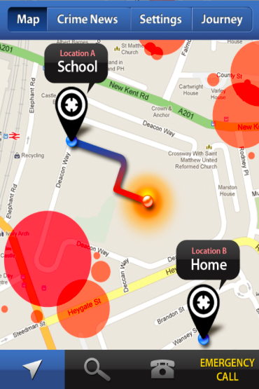

**Recommendations for Task 1:**

1. We need to change the naming of the tabs to avoid confusion. We could rename the tab “Journey” to “History” or “Records”.

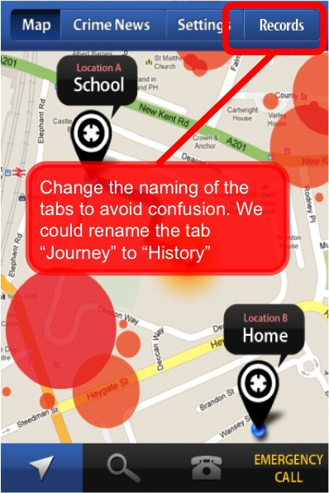

**Task 2 for Parent User:**

|  |  |  |  |
| --- | --- | --- | --- |
| **SECTION** | **TASK** | **RESULT** | **OBSERVATIONS** |
| Zone identification | Where is the crime and traffic zone in the map? | Fail | The user failed to differentiate between the colours of the zones on the maps.  **Why:** The colours we used to represent the zones were too similar – Amber & Red. |



**Recommendations for Task 2:**

1. We should change the colors of the zone and keep very different colors for each zone. We have given RED for crime zone and BLUE for Traffic sensitive zone.

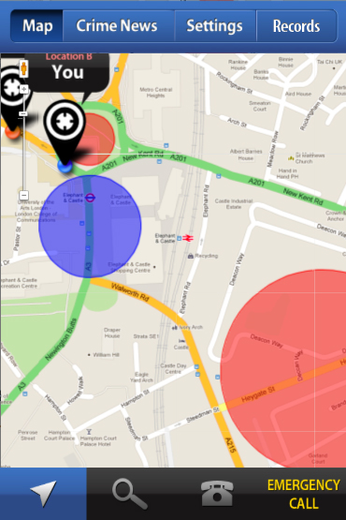

**Task 1 for Child User:**

|  |  |  |  |
| --- | --- | --- | --- |
| **SECTION** | **TASK** | **RESULT** | **OBSERVATIONS** |
| Answer Quiz | What can you do if you don't know the answer? | Fail | We still had used “More Info” as the text for the button and the user clicked all the options to get the right one.  **Why:** The button text is not providing enough information. |

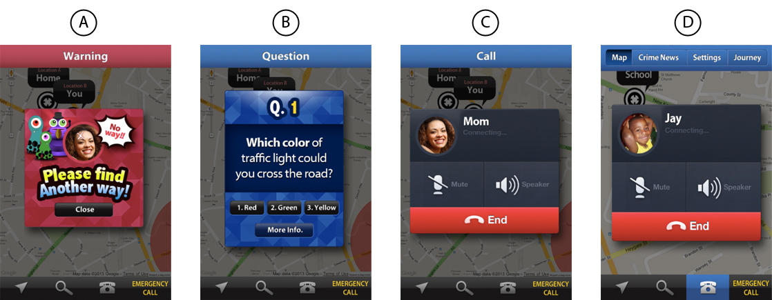

**Recommendations for Task 1:**

1. We should change the text of the button to “Watch Video” or “Video Hint” so that the user can understand that by taping the button and watching the video they will be able to answer the question. We had not made this change from the paper prototyping.

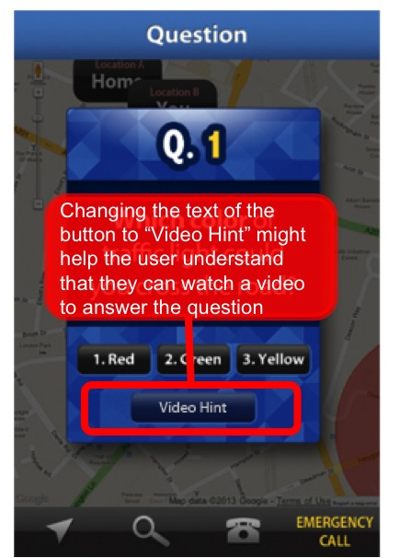

**REFLECTION:**

Choosing “children” as our user group proved to be a big drawback for us mainly during our usability testing. We were unable to find any child and their parent together to do our usability test, and our request to the schools were ignored by the management. In the end we were lucky enough to find one child and a parent together to do our test.

A usability test with one user is nearly equivalent to not doing the test at all. We need to test our product on as many different types of users to really understand the issues with our product. As a lesson learnt, when using children as a user group for a project, one should really consider all these problems in the beginning of the project and mark it as a major risk factor for the project. One should make proper arrangements for the getting the user research and the usability testing done. Preferably, the users could be asked if they would be available for the test which would make it a lot easier – we made the mistake of not asking the school if we could do a usability test when we conducted our survey.

**PROJECT LINKS:**

**Demo:** Child App: [www.banli.co/k](http://www.banli.co/k) Parent App: [www.banli.co/p](http://www.banli.co/p)

**Blog:** <http://lccmaim.wordpress.com>

**Presentation:** <http://www.banli.co/1.ppt>

**REFERENCES:**

**[1]** “Elephant & Castle safer roads petition reaches 2,000 signatures” Link: <http://www.london-se1.co.uk/news/view/6439>